
Tug Tales #31
DELAND’S ST 344 SAILOR KILLED IN WW2 IDENTIFIED
April 28, 2015 Dan Friend
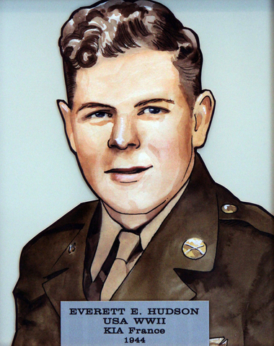
We now have the first image of a sailor killed in action on a DeLand Warboat. Private Everett Hudson was on DeLand’s ST 344 on that tragic day when it hit a mine during WW2. He was on the small Army tugboat when it exploded on July 20, 1944, in the outer harbor at Cherbourg, France. He was with the 335th Harbor Craft Company, the same one that Sergeant Ray Bishop of ST 474 was assigned to. All of this including the demise of ST 344 is verified on the website www.fieldsofhonor.com. Here’s what the website
contains:
“Pfc. Everett E. Hudson served with the 335th Harbor Craft Company, Transportation Corps, United States Army during World War II.
Hudson was from Harrisonville, NJ.
“The harbor craft company is organized for the purpose of ferrying to shore cargo from freighters and transports arriving in theaters of operation. The vessels may either be riding offshore at anchor in the open sea or more likely, anchored in a harbor. Cargo from the ships is loaded by Transportation Corps port company personnel onto barges. Then tugs, tow boats, or marine tractors propel the barges to the shore for unloading. Any cargo too heavy for the vessel's gear to lift is handled by a 60-ton floating crane.”
Hudson was killed in action, July 20, 1944, and now rests in the Ardennes American Cemetery, Neupre, Belgium. Hudson was awarded the Purple Heart Medal. On 20 July 1944 U.S. Army

Tugboat ST 344 blew up and sank after hitting a mine in the Grande Rade at Cherbourg Harbor, France. The U.S. Army tug boats were manned by Harbor Craft Company members.”

One of the captains of DeLand’s ST 474, Ray Bishop also mentions the tragedy in a letter home to his wife Thelma and indicates that he picked up a Warrant Officer friend after the explosion and brought him home. He either was already dead or died going home…it’s hard to tell from the way it is written. So at least one other man was killed in addition to Hudson and it would appear that ST 344 also worked out of Southhampton prior to D-Day service and its destruction at Cherbourg.
The Wall of Heroes honors the Gloucester County men and women who were killed in action or missing in action while serving in the U.S. military protecting our freedoms and rights. The Gloucester County Freeholder Board unveiled The Wall of Heroes on Nov. 11 at the Gloucester County Justice Complex featuring the likenesses of 100 Heroes. The Wall of Heroes consists of framed 5-by-8-inch translucent artistic renderings portraying reasonable likenesses of the persons whom the county is honoring. The wall represents all branches of the military and they are arranged by era.
Gloucester County, New Jersey.
_______________________________________________________________________

