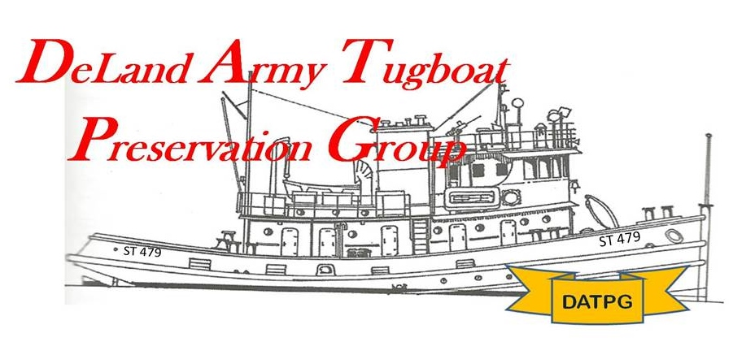
MYSTERY TUGS in 1948 SNOHOMISH TOW IDENTIFIED
9 25 2014 Dan Friend

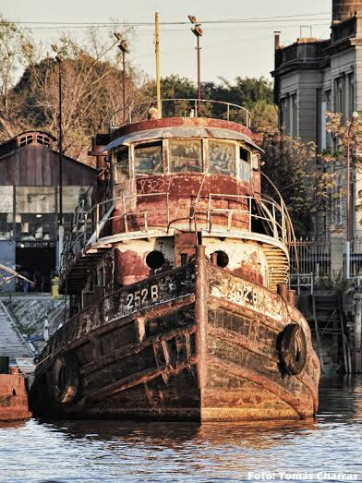
Bram Risseeuw, a former Dutch Navy radio operator and marine researcher from the Netherlands now living in Ireland has sent details on the identity of five of the six former US Army Design 257 ST’s that were towed by the Snohomish from Europe to Argentina in 1948: one of the longest tows on record. Until now, no one knew the ST numbers of the tugs that made the trip.

Risseeuw, a Janes Fighting Ships contributor, is mostly interested in the ships and armed forces of Paraguay, but found records that indicate that:
ST 85 became 253 B
ST 146 and ST 147 became 254 B and 255 B….but uncertain as to which is which….ST 164 and ST 167 became 252 B and 256 B, but once again, it is not certain which is which. (So: 252B – 256B were ST’s! DF)
Above: 252 B: World’s most forlorn looking ST still afloat!

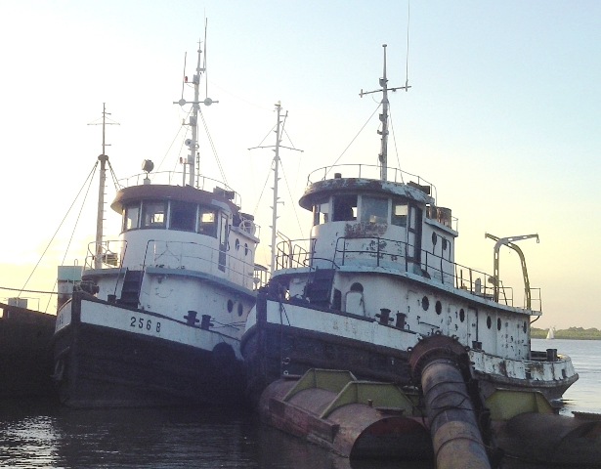
The owners were the Ministerio de Obras Publicas, Buenos Aires, Argentina. The 253 B sank in 1975 km 512.7 Rio Parana. Some or all of the others are still around including laid up ones .I have no idea of the 6th tug but the 251 B was of another type as was 257 B. The photos were found on the internet at Histarmar.com.ar

Bram Risseeuw

