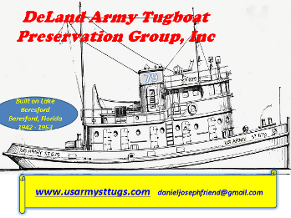
Tug Tales #29
ST 474’s WW2 Adventures in France
By Dan Friend
DeLand’s ST 474 was the 9th Design 257 US Army small tugboat which was completed by the American Machinery Corporation on Lake Beresford during WW2. It was turned over to the Army around November of 1943 and probably made it to Europe on a Liberty Ship. We had no details of its European service in WW2 until we received an email in October of 2013 from Mr. John Fairbairn:
“I read with interest the information you have posted about the US Army Transportation Corps tug ST 75 which was sunk by the Germans in the English Channel during WW II.
My father, Charles J. Fairbairn, was first mate on that tug at the time of its sinking…… FYI, I have attached a photo of my Dad, (3rd from the left) and crew of his second tug, the ST 474.”
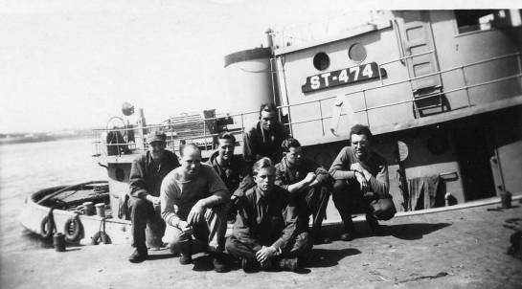
Written on back: “Dad’s 2nd tugboat - Cherbourg, France”
Charles would have been assigned to the DeLand-built tugboat from July of 1944 onwards. From the early delivery date it also seemed very likely ST 474 saw duty during D-Day at Normandy as well but no additional information than this photo had surfaced…until recently!
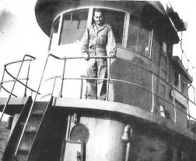
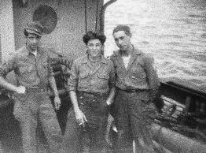
DATPG supporter Harold Bradeen of the DeLand Naval Air Station Museum recently met a visitor named Vivian Hallett who is the daughter of U. S. Army Master Sergeant Ray C. Bishop. He was one of the captains of ST 474 while it was at Cherbourg, France, from some point in 1944 until war’s end. She has sent quite a few photos to me, many of which are useable, of ST 474 and its crew…and we’ve learned quite a bit in the process about tug crew operations. For example, most tugs apparently had two complete crews most of the time Master Sergeant Ray C. Bishop working 24 hour shifts. We’ve known that the Captain ST 474 crews were a hodge podge affair with men from the Merchant Marine, Coast Guard, Naval Reserve, and Army all mixed in to accomplish the mission. I’ve also read that many of the men that could, ie, the Merchant Mariners or civilian crew, quit after one trip or sooner if they could escape. Since they were not in the regular military, they were not technically deserters but would be reported to the local draft board. Some said that was fine with them: it was safer in the Army! Commander Alfred Stanton, who wrote “Force Mulberry - The Planning And Installation Of Artificial Harbors Off U.S. Normandy Beaches In World War II” , said that he had to set up night patrol boats to keep seamen on the tugs just days ahead of the invasion as they were worked to near exhaustion to get ready for the D-Day effort.
Nevertheless it was a surprise to see a photo of three German prisoners on ST 474 …working as crew! The three young men were probably just as happy working on the tug as sitting in a POW camp, but I wonder how often other prisoners were put to work on our boats and ships? Here’s the photo with the lucky trio.
Ray C. Bishop entered the Army in WW2 and married his lifetime partner Thelma. This lady is still with us today at the tender young age of 94, and recently gave an oral interview on Ray’s WW2 work which helped to fill in some of the details. For example, Ray mentioned to her that two tugs were lost while he was working with the ST’s at Cherbourg Harbor and that he lost a good friend on one of them. Almost certainly one of those was DeLand’s own ST 344 which hit a mine on July 20, 1944, in the Cherbourg Harbor Grand Rade (outer harbor) and exploded. The 2nd loss is somewhat of a mystery as no other small tug is recorded as lost at Cherbourg Harbor during the war.
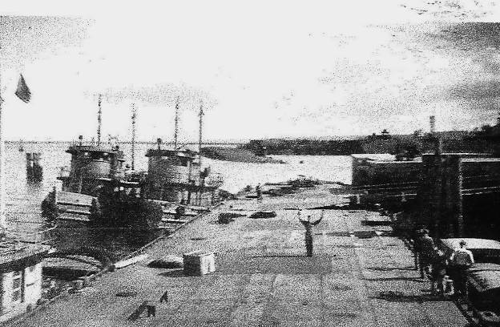
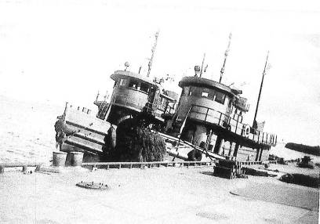
By the time the allies finally took Cherbourg Harbor from the Germans several weeks after D-Day it had been pretty much destroyed. The harbor would not be ready for serious work for months, and even moving around in the harbor long after the Germans were gone was dangerous work due to many types of mines, including a new type that worked from water pressure. Certainly the tug crews assigned to Cherbourg Harbor had their dangerous work cut out for them. All of these photos are assumed to be from Cherbourg unless noted; here’s a photo of their tie-up pier:
Written on back: “Sinking ship in the back. This is where we would tie up after each job by the control point.”

“ST 340 & ST 15”

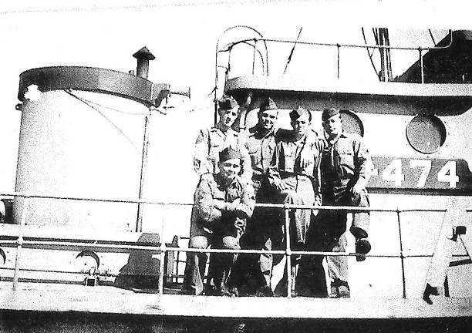
Here are a few of the ST 474 crew photographs with the words written on the back of each:
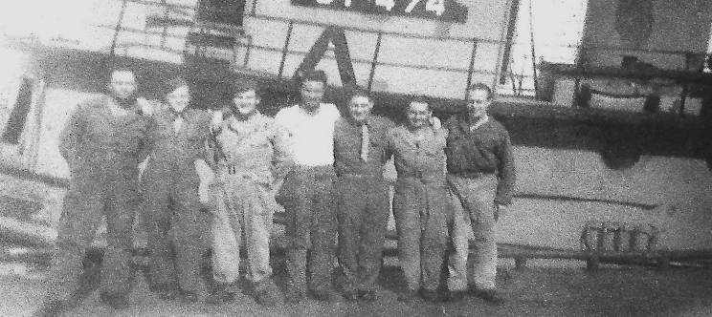
“We’re all here but my seamen wouldn’t dress up.”
“Neimier-Engineer, Flash, Neary-seaman, Vinson, Ehrlick, Ray Bishop-Master of the Boat, Pitcher-cook”
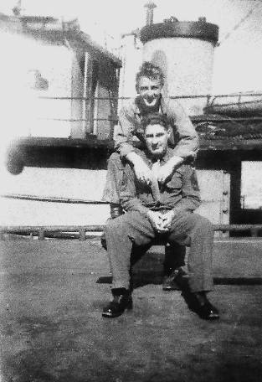
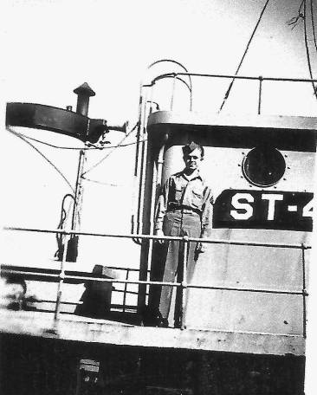
“Flash the Oiler” “Taylor & Ehrlick”
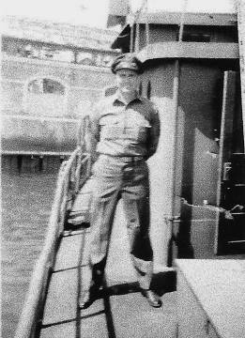
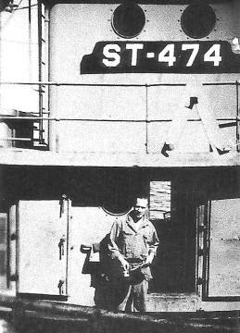

“Master Sergeant Neimier” “Boat Master Ray C. Bishop”
Quite a few other ST’s are mentioned in the various photographs or a number is clearly visible which also helps verify their European service, and obviously if they were at Cherbourg there’s a very good chance they served at D-Day Normandy. These ST’s are:

ST 15, 340, 489, 689, 780 & 743. (Two others are possibilities: ST 749 & 71_, )
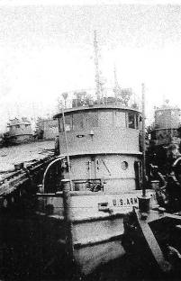
Here are a few photos of these ST’s at Cherbourg or during the final trip to Antwerp at war’s end that Ray made with his crew:
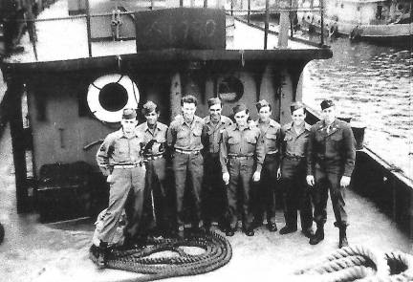
ST 71? Probably Antwerp ST 780: “Luther, Lozans, Fedociwicz, Tachas, Ray Bishop, Red,
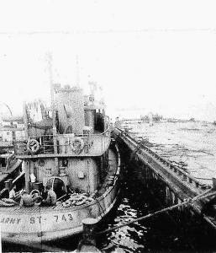
Crocker, WO Jones -probably Ray’s earlier ST assignment? This boat was at Normandy D-Day!! He also indicates he was on ST 489 as well….
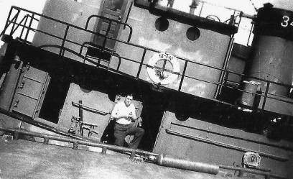

ST 743 “Tippy on ST 340”

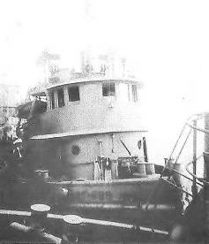

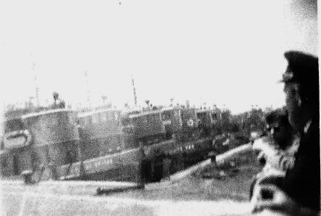

ST’s at Antwerp at war’s end……...ready for surplus sale!

Marked
“ST 689”
on back

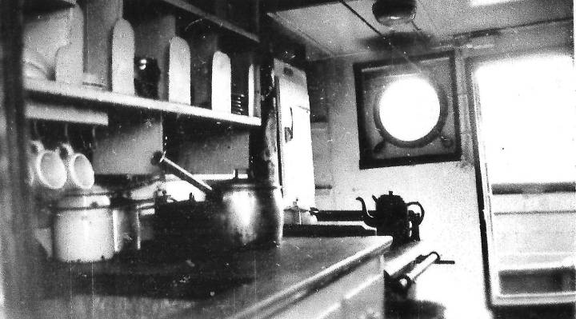

ST 474 Kitchen area “…the best part of the boat”
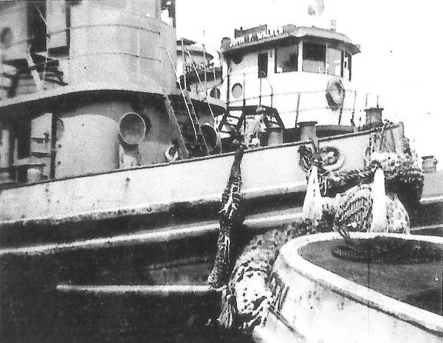

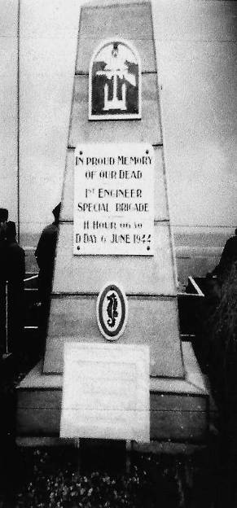
Two ST’s awaiting sale at Antwerp…..
one is the “John F. Walker”
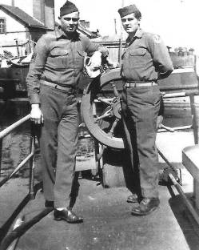

“Sgt Neimier the engineer and Neary the Seaman at the back wheel of ST 474”

Monument on Omaha Beach to the men of the 1st Engineer Special Brigade. ST’s were assigned to this group during the D-Day invasion.
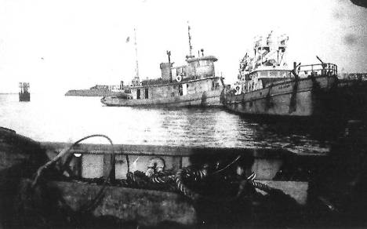
“Central point where we tied up when we get done with different jobs. ST 15 and fireboat and the back of ST 474”
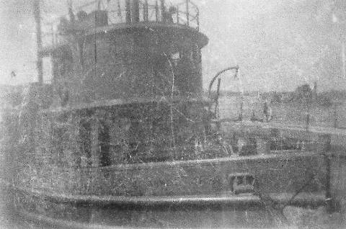
“This is old ST 489. The old boat I used to be on. It is on dry dock when the prop was bent and skin was bent.. you know…I wrote you about it. Was done on the beaches. Top of the ST is where the wheelhouse is where I drive it….” Master Sergeant Ray C. Bishop - Captain- ST 474
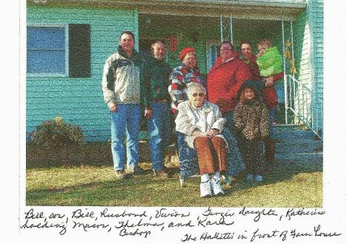
Undoubtedly we will find out more from Ray’s wife Thelma and daughter Vivian as they sort through his letters and records but this group of photographs has already greatly expanded our knowledge of WW2 ST operations and the history of DeLand’s ST 474 in particular. We are very grateful to both of these ladies for sharing this unique history with us!

